Homogenous Transformations:

[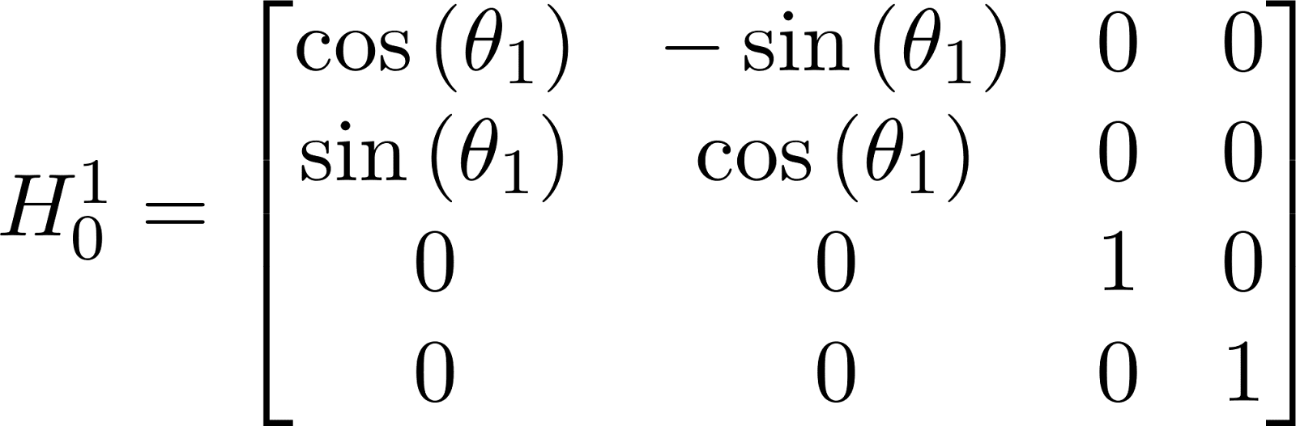](https://www.codecogs.com/eqnedit.php?latex=H_0%5E1%20%3D%20%5Cbegin%7Bbmatrix%7D%20%5Ccos%5Cleft(%5Ctheta%20_%7B1%7D%5Cright)%20%26%20-%5Csin%5Cleft(%5Ctheta%20_%7B1%7D%5Cright)%20%26%200%20%26%200%5C%5C%5C%5C%20%5Csin%5Cleft(%5Ctheta%20_%7B1%7D%5Cright)%20%26%20%5Ccos%5Cleft(%5Ctheta%20_%7B1%7D%5Cright)%20%26%200%20%26%200%5C%5C%5C%5C%200%20%26%200%20%26%201%20%26%200%5C%5C%5C%5C%200%20%26%200%20%26%200%20%26%201%20%5Cend%7Bbmatrix%7D#0)

[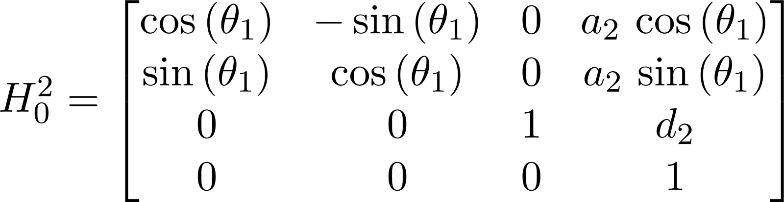](https://www.codecogs.com/eqnedit.php?latex=H_0%5E2%20%3D%20%5Cbegin%7Bbmatrix%7D%20%5Ccos%5Cleft(%5Ctheta%20_%7B1%7D%5Cright)%20%26%20-%5Csin%5Cleft(%5Ctheta%20_%7B1%7D%5Cright)%20%26%200%20%26%20a_%7B2%7D%5C%2C%5Ccos%5Cleft(%5Ctheta%20_%7B1%7D%5Cright)%5C%5C%5C%5C%20%5Csin%5Cleft(%5Ctheta%20_%7B1%7D%5Cright)%20%26%20%5Ccos%5Cleft(%5Ctheta%20_%7B1%7D%5Cright)%20%26%200%20%26%20a_%7B2%7D%5C%2C%5Csin%5Cleft(%5Ctheta%20_%7B1%7D%5Cright)%5C%5C%5C%5C%200%20%26%200%20%26%201%20%26%20d_%7B2%7D%5C%5C%5C%5C%200%20%26%200%20%26%200%20%26%201%20%5Cend%7Bbmatrix%7D#0)

[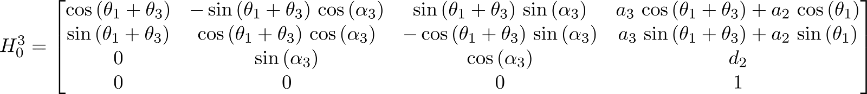](https://www.codecogs.com/eqnedit.php?latex=H_0%5E3%20%3D%20%5Cbegin%7Bbmatrix%7D%20%5Ccos%5Cleft(%5Ctheta%20_%7B1%7D%2B%5Ctheta%20_%7B3%7D%5Cright)%20%26%20-%5Csin%5Cleft(%5Ctheta%20_%7B1%7D%2B%5Ctheta%20_%7B3%7D%5Cright)%5C%2C%5Ccos%5Cleft(%5Calpha%20_%7B3%7D%5Cright)%20%26%20%5Csin%5Cleft(%5Ctheta%20_%7B1%7D%2B%5Ctheta%20_%7B3%7D%5Cright)%5C%2C%5Csin%5Cleft(%5Calpha%20_%7B3%7D%5Cright)%20%26%20a_%7B3%7D%5C%2C%5Ccos%5Cleft(%5Ctheta%20_%7B1%7D%2B%5Ctheta%20_%7B3%7D%5Cright)%2Ba_%7B2%7D%5C%2C%5Ccos%5Cleft(%5Ctheta%20_%7B1%7D%5Cright)%5C%5C%5C%5C%20%5Csin%5Cleft(%5Ctheta%20_%7B1%7D%2B%5Ctheta%20_%7B3%7D%5Cright)%20%26%20%5Ccos%5Cleft(%5Ctheta%20_%7B1%7D%2B%5Ctheta%20_%7B3%7D%5Cright)%5C%2C%5Ccos%5Cleft(%5Calpha%20_%7B3%7D%5Cright)%20%26%20-%5Ccos%5Cleft(%5Ctheta%20_%7B1%7D%2B%5Ctheta%20_%7B3%7D%5Cright)%5C%2C%5Csin%5Cleft(%5Calpha%20_%7B3%7D%5Cright)%20%26%20a_%7B3%7D%5C%2C%5Csin%5Cleft(%5Ctheta%20_%7B1%7D%2B%5Ctheta%20_%7B3%7D%5Cright)%2Ba_%7B2%7D%5C%2C%5Csin%5Cleft(%5Ctheta%20_%7B1%7D%5Cright)%5C%5C%5C%5C%200%20%26%20%5Csin%5Cleft(%5Calpha%20_%7B3%7D%5Cright)%20%26%20%5Ccos%5Cleft(%5Calpha%20_%7B3%7D%5Cright)%20%26%20d_%7B2%7D%5C%5C%5C%5C%200%20%26%200%20%26%200%20%26%201%20%5Cend%7Bbmatrix%7D#0)

Solved Inverse Kinematics:





